From: Helen Lines [mailto:hlines@communityfirst.org.uk]
Sent: 06 April 2009 14:19
To: White, Ian
Subject: Link scheme coverage/Performance indicator data
Dear Ian

As requested please find listed below all the parishes that are currently uncovered by a Link scheme or other social car scheme:

Ashton Keynes – Covered by an informal scheme called: Ashton Keynes Helpline (emergencies only)

Braydon- Community not interested in developing a scheme/need for a Link scheme not established

Broad Hinton- Community not interested in developing a scheme/need for a Link scheme not established

Buttermere – Currently under development/investigation

Clarendon Park- Community not interested in developing a scheme/need for a Link scheme not established

Ham – Currently under development/investigation

Marston Meysey - Community not interested in developing a scheme/need for a Link scheme not established

Pitton & Farley- Community not interested in developing a scheme/need for a Link scheme not established

Purton - Community not interested in developing a scheme/need for a Link scheme not established

Shalbourne – Currently under development/investigation

Stapleford - Community not interested in developing a scheme/need for a Link scheme not established

Sopworth - Community not interested in developing a scheme/need for a Link scheme not established

Tidcombe & Fosbury – Currently under development/investigation

Wootton Bassett – Currently under development/investigation

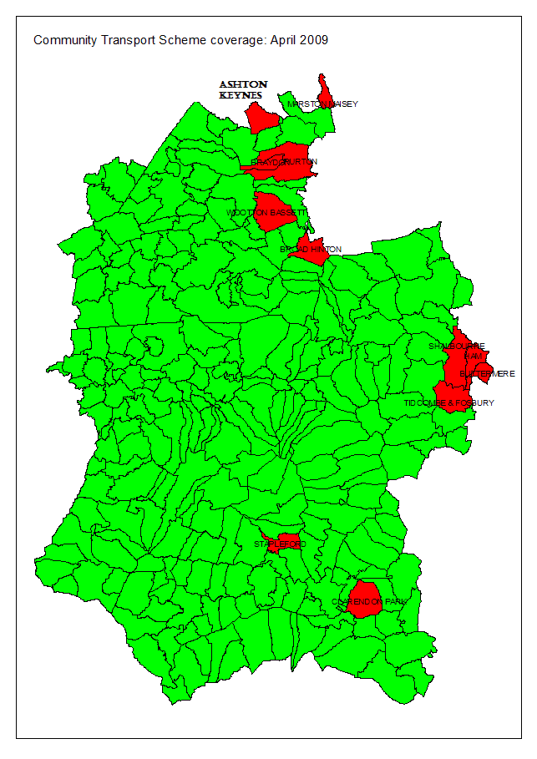
I hope this helps and if you have any further queries, please do not hesitate to contact me.

Kind regards,

Helen Lines
Link Project Officer

